
High Level Design
Improve YMCA Onboarding Process

Table of Contents
Roadmap 3
Key Considerations 4
Challenges per Intervention 4
Interventions 5
Intervention One: Centralized Knowledge Base & FAQ System 5
Intervention Two: Video Tutorials & Step-by-Step Guides 6
Intervention Three: Mentorship Program 7
Intervention Four: Progress Dashboard 8
Intervention Five: Interactive Training Workshops 9
Intervention Six: Collaborative Teacher Network 10
References 11

Roadmap
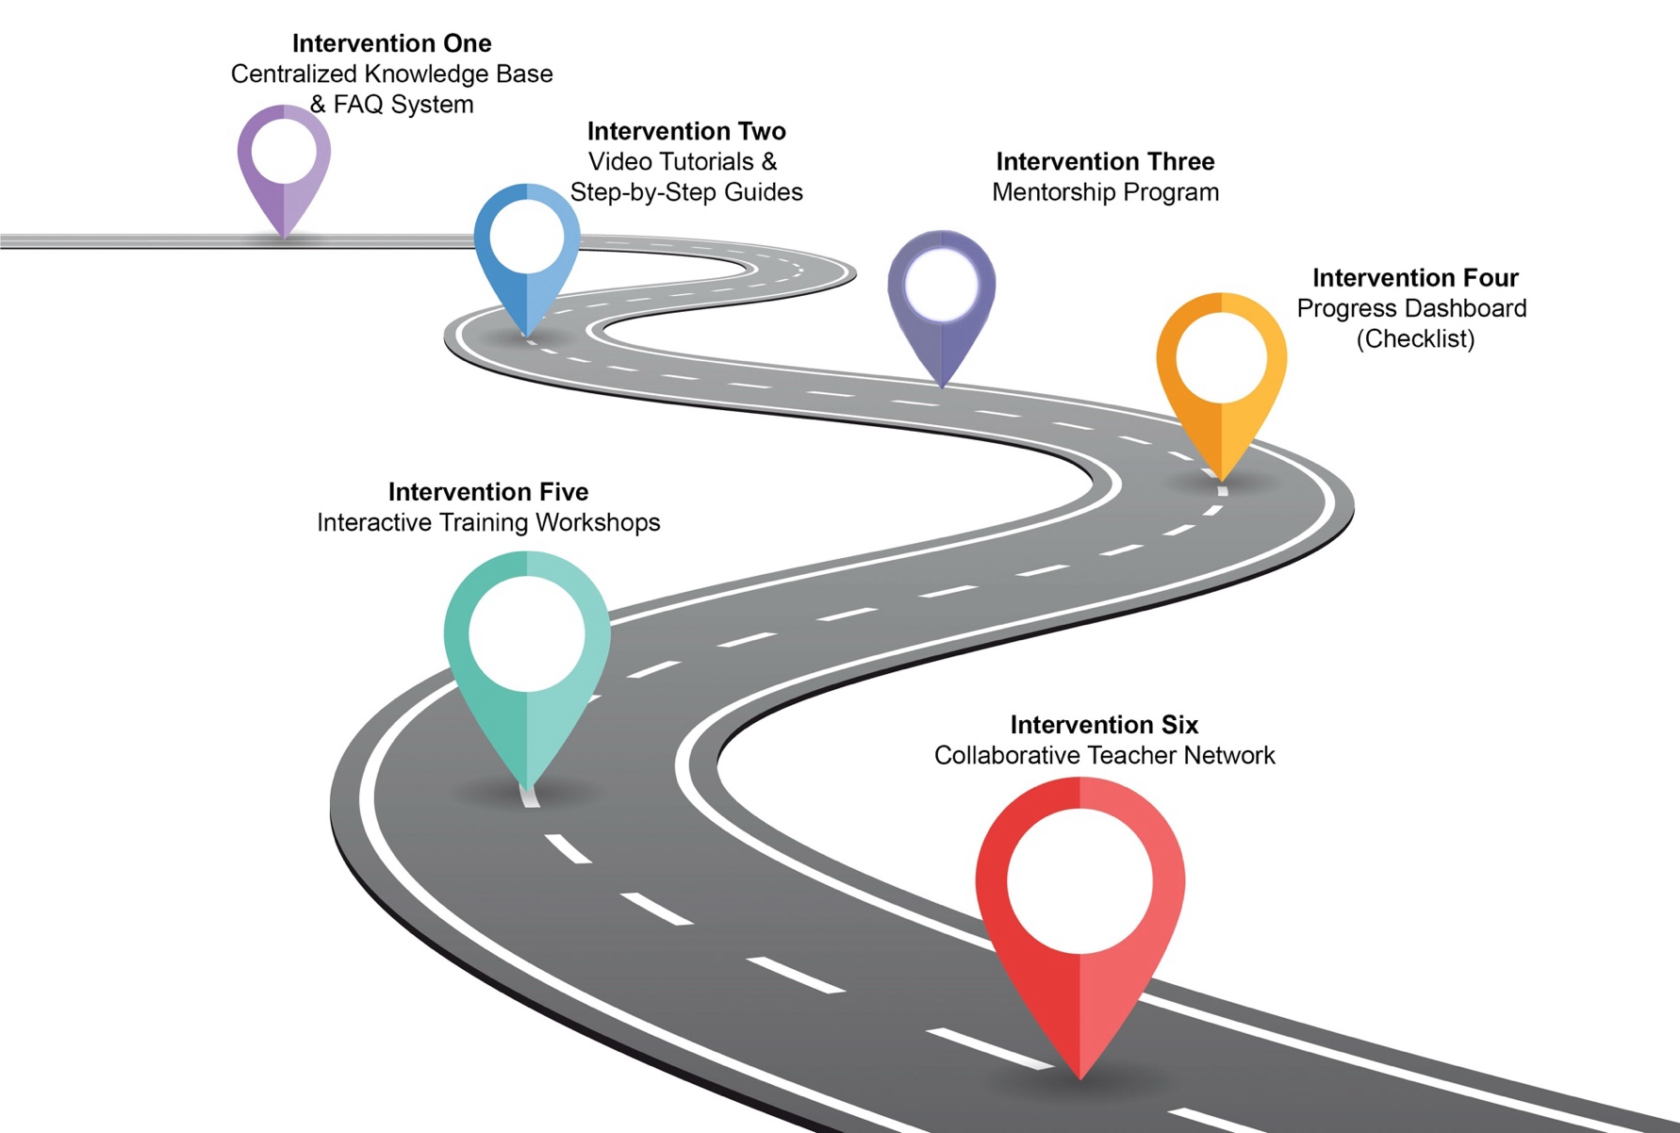
Job one
Improvement in the Onboarding Process and Smoother Management of Virtual Classes

Key Considerations
- After a thorough analysis of the onboarding process at the YMCA, several issues have been identified. The proposed interventions are presented without consideration of time and budget constraints, as these limitations have not yet been specified. The interventions are listed based on their effectiveness.
- The LMS is already active and used by employees; however, it is not updated regularly. Additionally, it lacks a FAQ page.
- During the onboarding process, new hires are contacted by different team members to complete various tasks, such as finishing training courses on the LMS and updating the “Roster,” an Excel sheet used to record student contact information and provide instructions for sending eBook passwords. A checklist outlining all the onboarding steps would be helpful in reducing back-and-forth emails and minimizing teachers' workload. However, this checklist is not currently provided to new teachers.

Challenges per Intervention
Implementing these interventions bring some challenges as well. Some potential challenges for each intervention are as follows:

Centralized Knowledge Base & FAQ System | Adding a FAQ page to LMS requires initial setup, content creation, and ongoing updates.  Teachers must actively seek information instead of receiving direct support. Some may prefer real-time assistance over reading FAQs.
Video Tutorials & Step-by-Step Guides | Video tutorials are time-consuming to create and update, especially when software interfaces change. Some teachers may struggle with self-directed learning. It lacks the possibility of instant question and answer.
Mentorship Program | Finding and matching compatible mentors and mentees can be challenging. Mentors must be committed and available for regular check-ins.
Progress Dashboard (Checklist) | Upon hiring each teacher is provided with the credentials to have access to LMS but there is no checklist available to make sure they have passed all the required training courses. This intervention is not challenging and is not costly.
Interactive Training Workshops | Scheduling conflicts may prevent some teachers from attending. The workshops require facilitators and resources, making it more time-intensive. Some may prefer self-paced learning instead of live sessions.
Collaborative Teacher Network | Needs active participation to remain useful. There is a chance that employees don’t check the network frequently or even put it on mute.  Discussions may lack structure or off-topic.  Some teachers may prefer one-on-one support rather than group discussions.

Interventions

Intervention One: Centralized Knowledge Base & FAQ System
Description | Provides teachers with a structured, user-friendly resource to quickly access answers to common questions about Google Classroom and Meet. Aims to reduce confusion, minimize repetitive inquiries, and empower teachers with self-service solutions.
Performance Objective | Teachers will independently resolve at least 90% of their questions without requiring further support, reducing the workload on support teams.
Genre | Knowledge Base / Self-Help Resource
Communication Medium | Online FAQ Page (hosted via LMS, website, or internal portal)
Advantages | - Available 24/7 for immediate access.  - Minimizes repetitive support requests.  - Scalable with real-time updates.  - Easily expandable with new content.
Disadvantages/Limitations | - Requires initial setup and continuous maintenance.  - Teachers must take initiative to access information.  - Some users may prefer direct support.
Conventions | - FAQ organized by topic categories.  - Clear, concise formatting for quick reference.  - Search functionality for easy navigation.  - Links to relevant resources and tutorials.  - Regular updates based on feedback and new inquiries.

Intervention Two: Video Tutorials & Step-by-Step Guides

Description | Engaging video tutorials and step-by-step guides that cover essential Google Classroom and Meet features. Designed to enhance teachers' technical proficiency through visual, self-paced learning.
Performance Objective | Teachers will independently complete 95% of their tasks on Google Classroom and Meet without requiring live support or intervention.
Genre | Digital Training / Instructional Videos
Communication Medium | Video Library (hosted via LMS, website, or YouTube)
Advantages | - Visual, step-by-step guidance.  - Flexible, self-paced learning.  - Standardized instructions ensure consistency.  - Reduces need for live training.
Disadvantages/Limitations | - Requires significant time and resources to produce and update content.  - Teachers need to seek out and engage with videos.  - Regular updates needed when software changes.  - Some learners prefer hands-on training.
Conventions | - Videos categorized by topics and functions.  - Tutorials kept between 3-5 minutes for easy consumption.  - Accompanying guides for detailed instructions.  - Feedback section for future improvements.  - Updates made in response to user feedback.

Intervention Three: Mentorship Program

Description | Pairs new teachers with experienced colleagues to provide personalized guidance and support. Aims to build confidence, improve teaching practices, and increase retention through collaborative mentorship.
Performance Objective | 85% of new teachers will report increased confidence and satisfaction after completing the mentorship program.
Genre | Peer Support / Professional Development
Communication Medium | One-on-one meetings, email check-ins, online forums, or virtual/in-person sessions.
Advantages | - Personalized, tailored guidance.  - Supports faster adaptation to institutional culture.  - Encourages peer learning and collaboration.  - Increases overall teacher satisfaction and retention.
Disadvantages/Limitations | - Requires time and commitment from both mentors and mentees.  - Success depends on mentor-mentee relationship dynamics.  - Coordination and monitoring required for effectiveness.
Conventions | - Mentors have 3+ years of teaching experience.  - Regularly scheduled check-ins to ensure progress.  - Structured framework with defined goals and milestones.  - Feedback collected at program completion for improvements.

Intervention Four: Progress Dashboard (Checklist)

Description | An interactive online dashboard that tracks teachers' onboarding progress, highlights completed steps, and identifies areas requiring further assistance. Aims to ensure timely completion of onboarding tasks and personalized support.
Performance Objective | Teachers will complete 100% of required onboarding steps within the designated timeframe. The dashboard will flag teachers needing additional support.
Genre | Tracking & Analytics / Performance Monitoring
Communication Medium | Online dashboard (hosted via LMS or internal platform)
Advantages | - Provides real-time insights into teacher progress.  - Identifies specific areas where support is needed.  - Promotes accountability and timely task completion.  - Automates tracking to reduce manual oversight.
Disadvantages/Limitations | - Requires seamless system integration and training.  - May increase pressure or anxiety among some teachers.  - Relies on accurate data input for effective tracking.
Conventions | - Progress displayed visually by task category.  - Automated alerts and reminders for incomplete tasks.  - Option for teachers to request assistance directly from the dashboard.  - Customizable to reflect institutional priorities.

Intervention Five: Interactive Training Workshops

Description | Live, instructor-led workshops where teachers practice using Google Meet and Classroom features with real-time guidance. Designed to build technical proficiency through hands-on application.
Performance Objective | Teachers will demonstrate proficiency in using key Google Classroom and Meet features immediately after completing the workshop.
Genre | Live Training / Practical Skill Development
Communication Medium | In-person or virtual workshops (via Zoom or Google Meet)
Advantages | - Provides real-time feedback and personalized assistance.  - Encourages active engagement and skill application.  - Facilitates collaboration and peer learning.  - Allows immediate clarification of doubts.
Disadvantages/Limitations | - Requires careful scheduling to accommodate all teachers.  - Limited flexibility for those unable to attend.  - Some prefer self-paced learning formats.  - May require multiple sessions for complete mastery.
Conventions | - Step-by-step demonstrations by instructors.  - Breakout activities for individual and group practice.  - Recorded sessions available for later review.  - Post-workshop surveys to gather feedback for future sessions.

Intervention Six: Collaborative Teacher Network

Description | An online platform where teachers can exchange ideas, share best practices, and seek support from peers. Designed to foster collaboration, ongoing professional development, and a strong knowledge-sharing community.
Performance Objective | High engagement levels with at least 70% of teachers actively participating in discussions and sharing solutions.
Genre | Community-Based Learning / Professional Networking
Communication Medium | Online boards, messaging platforms, LMS, or social media
Advantages | - Encourages continuous collaboration and idea-sharing.  - Provides a platform for discussing challenges and solutions.  - Accessible anytime for ongoing professional support.  - Creates a strong support network for educators.
Disadvantages/Limitations | - Requires consistent participation and engagement.  - May become disorganized without clear moderation.  - Some teachers may prefer one-on-one mentorship.  - Content moderation is necessary to maintain quality.
Conventions | - Regularly scheduled discussions and updates.  - Clear guidelines for content sharing and discussion.  - Opportunities for mentorship within the network.  - Active moderation to ensure quality and relevance.

Note: Since no precise performance objective data was available on the YMCA website or in reports, we made rough estimations for each intervention. To establish specific targets, we could not rely solely on benchmarks from other industries, as the YMCA operates within its own unique organizational culture and policies. Conducting a survey or analyzing internal statistics would provide more accurate insights and help set realistic and data-driven performance objectives.

References

Frögéli, E., Jenner, B., & Gustavsson, P. (2023). Effectiveness of formal onboarding for facilitating organizational socialization: A systematic review. PLOS ONE, 18(2), e0281823. https://doi.org/10.1371/journal.pone.0281823
Pinco, O., Salanta, I. I., Beleiu, I. N., & Crisan, E. L. (2024). The onboarding process: A review. Vilakshan - XIMB Journal of Management. https://doi.org/10.1108/XJM-01-2024-0008
Smith, C. E., Matthews, R. A., Mills, M. J., Hong, Y.-H., & Sim, S. (2022). Organizational Benefits of Onboarding Contingent Workers: An Anchoring Model Approach. Journal of Business and Psychology, 37(3), 525–541. https://doi.org/10.1007/s10869-021-09757-0
YMCAgta.org. (n.d.). Retrieved March 16, 2025, from https://secure.livechatinc.com/customer/action/open_chat?license_id=11870253&group=0&embedded=1&widget_version=3&unique_groups=0&organizationId=b0692e16-9e54-4b88-a92f-374c90a5c566&use_parent_storage=1

